Newsletter
February 2019 – Issue 3
Granville Road, NW2

Scheme update
The New Granville LLP have recently organised a number of events at Childs Hill Baptist Church about the landscaping of the green spaces at New Granville. We invited you to these events, so you can have your say on the planting and play equipment in the communal areas of the new scheme.

Projected timeline for programme
Date | Programme
February – March 2019 | Tree removal
1 July 2019 | Start on site
July – December 2019 | Virgin Media diversion works/ electric diversion works / Thames Water diversion works
July 2019 – July 2020 | BT diversion works
August 2019 – February 2020 | Gas diversion works
July 2019 – April 2022 | Phase 1 construction works
October – November 2019 | Phase 1 demolition of pram sheds and garages
February 2020 – October 2022 | Phase 2 construction works
March – May 2020 | Demolition of Beech Court, pram sheds and garages

Timeline of landscaping events

- Introductory event on 29 November 2018 – we introduced residents to One Housing, Mulalleys and the LLP.
- Landscaping workshops on 13 and 15 December 2018 – we organised these workshops to encourage discussions about green spaces and play areas at New Granville.
- Presentation event on 15 January 2019 – we showed how New Granille LLP incorporated residents’ feedback into the landscaping designs. To give you an idea of what changes were made, we have enclosed copies of the presentation boards. If you’ve any questions please contact the resident liaison officer or the regeneration team. You can find their details on the back page of this newsletter.

Tree removal programme
As part of the agreed planning permission, tree removal contractors, Artemis Tree Services will commence work on 21 February 2019 and the works will start in strategic locations across the estate. These works will see the removal of 92 trees across the estate, along with the trimming of a further 27 trees, to allow construction of the development to start. The tree removal programme will take place over a four to six-week period.
As requested by you, we will keep some of the logs removed for use by you in creating features around the estate. There will be noise during the works, however Artemis Tree Services will make sure that works are undertaken in a safe and controlled manner and that disruption to residents is kept to a minimum.
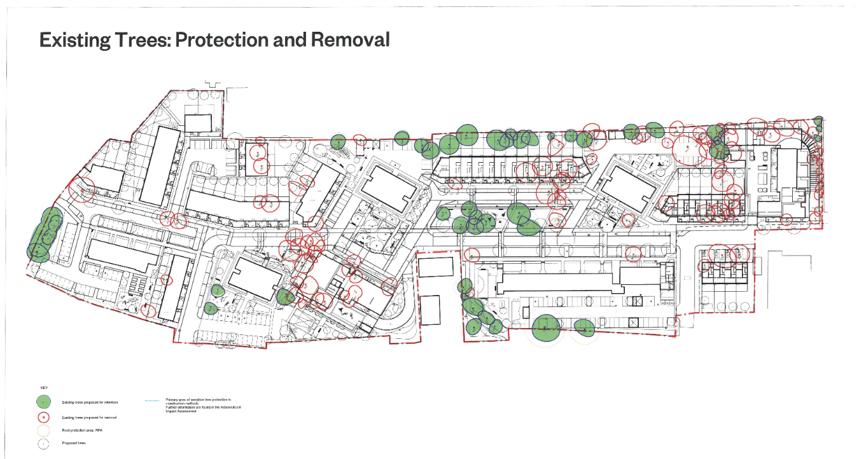

Considerate constructors
Mulalley is a founder member of the Considerate Constructors Scheme, a non-profit making, independent organisation founded by the industry to improve its image.
The scheme operates independent inspectors who monitor site activities and overall presence of the site, with emphasis on:
- care about appearance
- respect the community
- protect the environment
- secure everyone’s safety
- value their workforce.

Contact information
One Housing
Briony Rogers 020 7428 8533
Marina Cox 020 7428 4204
Or email newgranville@onehousing.co.uk
For further information regarding the scheme, visit www.newgranville.co.uk

